**Project Design Phase-II**

**Data Flow Diagram & User Stories**

|  |  |
| --- | --- |
| **DATE:** | **26-06-2025** |
| **Team ID :** | **LTVIP2025TMID55625** |
| **Project Name :** | **ResolveFlow: Online Complaint Registration and Management System** |

## 1. Data Flow Diagram (DFD) - Level 0 Context Diagram

This Level 0 Context Diagram provides a high-level overview of the Online Complaint Registration and Management System, illustrating its main interactions with external entities.

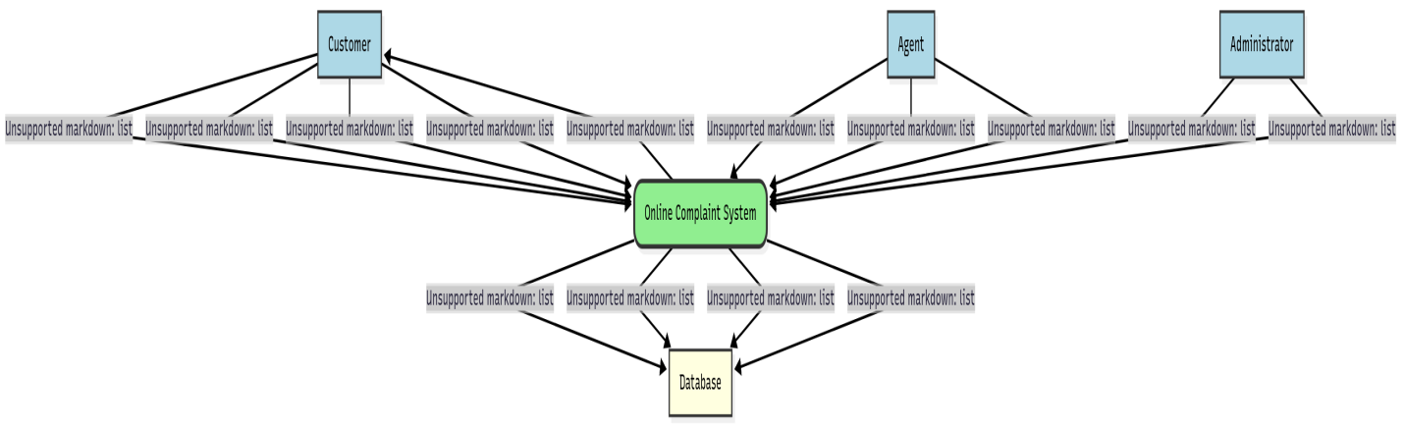

**Explanation of DFD Components:**

* **Entities (Squares):** External entities that interact with the system (Customer, Agent, Administrator, Database).
* **Process (Circles/Rounded Rectangles):** The entire system treated as one process (Online Complaint System).
* **Data Flows (Arrows):** Show the direction of data movement between entities and the system.
  + **1. Submit Complaint:** Customer sends complaint details.
  + **2. Track Status:** Customer requests/receives status updates.
  + **3. Receive Notification:** Customer gets alerts (email/SMS).
  + **4. Chat with Agent:** Customer sends/receives chat messages.
  + **5. Manage Complaints:** Agent accesses and updates complaint information.
  + **6. Chat with Customer:** Agent sends/receives chat messages.
  + **7. Update Status:** Agent changes complaint status.
  + **8. Oversee System:** Admin accesses system-wide reports/controls.
  + **9. Assign Complaints:** Admin assigns complaints to agents.
  + **10. Send Notifications:** System sends notifications to Customer.
  + **11. Customer Info:** System stores customer profile data.
  + **12. Complaint Data:** System stores complaint details, attachments, history.
  + **13. Agent/Admin Data:** System stores agent and admin profile data, roles.
  + **14. Retrieve Data:** System fetches data from the database.

## 2. User Stories

User Stories translate functional requirements into concise, user-centric narratives. They are expressed in the format: "As a [role], I want to [action] so that [benefit]." Each story should be testable via Acceptance Criteria.

|  |  |  |  |  |
| --- | --- | --- | --- | --- |
| **User Story ID** | **As a...** | **I want to...** | **So that...** | **Acceptance Criteria (Conditions of Satisfaction)** |
| **US-FR1.1.1** | New Customer | register for an account securely | I can access the complaint management system. | 1. User can navigate to a clear registration page. 2. User can provide email, password, and basic profile info. 3. Account creation is confirmed securely. |
| **US-FR1.1.2** | Registered User | log in to the system with my credentials | I can access my personalized dashboard and relevant functionalities. | 1. User can enter email/username and password on a login page. 2. Successful login redirects to dashboard. 3. Incorrect credentials show an error message. |
| **US-FR1.1.3** | User | reset my password if I forget it | I can regain access to my account without contacting support. | 1. "Forgot Password" link is available. 2. User receives a secure password reset link/code via email. 3. User can set a new password via the link/code. |
| **US-FR1.1.4** | System User | have access to features based on my role (Customer, Agent, Administrator) | I only see and can perform actions relevant to my responsibilities. | 1. Customer sees only customer-specific dashboard/features. 2. Agent sees only agent-specific dashboard/features. 3. Admin sees only admin-specific dashboard/features. |
| **US-FR1.2.1** | Authenticated Customer | submit a new complaint through an online form | my issue is formally recorded and sent to the support team. | 1. User can find and click "Submit Complaint." 2. Form loads correctly. 3. User can fill and submit the form. |
| **US-FR1.2.2** | Authenticated Customer | provide detailed information in the complaint form | the support team has all necessary context to understand my issue. | 1. Form includes fields for description, type, contact. 2. Mandatory fields are clearly marked. 3. User can input sufficient text description. |
| **US-FR1.2.3** | Authenticated Customer | attach supporting files (images, documents) to my complaint | I can provide visual evidence and documentation related to my issue. | 1. Form allows file uploads (drag-and-drop or browse). 2. Supports common file types (JPG, PNG, PDF). 3. Attached files are visible post-submission. |
| **US-FR1.3.1** | Customer | view all my submitted complaints and their current statuses on my dashboard | I can easily keep track of my issues in one place. | 1. Dashboard displays a list of all complaints submitted by the user. 2. Each complaint entry clearly shows its current status. |
| **US-FR1.3.2** | Customer | see real-time updates on my complaint status on the dashboard | I am immediately aware of any progress or changes without manual refresh. | 1. Complaint status on dashboard updates automatically when changed by an agent. |
| **US-FR1.3.3** | Agent | view, update, and manage complaints assigned to me | I can efficiently process and resolve my workload. | 1. Agent dashboard shows a list of assigned complaints. 2. Agent can open a complaint, view details, and change its status. 3. Agent can add internal notes. |
| **US-FR1.3.4** | Administrator | view all complaints in the system, their statuses, and assigned agents | I can oversee the entire complaint handling process. | 1. Admin dashboard provides a comprehensive list of all complaints. 2. Complaints can be filtered/sorted by status, agent, type. |
| **US-FR1.3.5** | Administrator | assign and reassign complaints to specific agents | I can ensure complaints are handled by the most appropriate personnel. | 1. Admin can select a complaint and assign it to an available agent. 2. Admin can reassign an already assigned complaint to a different agent. |
| **US-FR1.4.1** | Customer/Agent | communicate directly with my assigned agent/customer via an in-app chat feature | I can clarify details and get quick responses without external tools. | 1. A chat interface is integrated into the complaint details view. 2. Both user roles can send and receive text messages. |
| **US-FR1.4.2** | Customer/Agent | view the full chat history for a specific complaint | I have complete context of past conversations and don't need to repeat myself. | 1. All messages exchanged in the in-app chat are saved. 2. The full history is accessible by both customer and agent anytime for that complaint. |
| **US-FR1.4.3** | Customer | receive automated notifications (email/SMS) for key complaint events | I am proactively informed about important updates on my complaint. | 1. User receives confirmation after submitting a complaint. 2. User receives notification when status changes. 3. User receives notification when agent is assigned. |
| **US-FR1.5.1** | System | reliably store and retrieve all user and complaint data | the system maintains accurate records and can function consistently. | 1. All submitted complaints, user profiles, chat messages, and attachment metadata are saved to the database. 2. This data can be retrieved accurately and quickly. |